SAFE OPERATING PROCEDURE
MINE EXCAVATION



ODISHA MINING CORPORATION LTD.
KODINGAMALI BAUXITE MINE
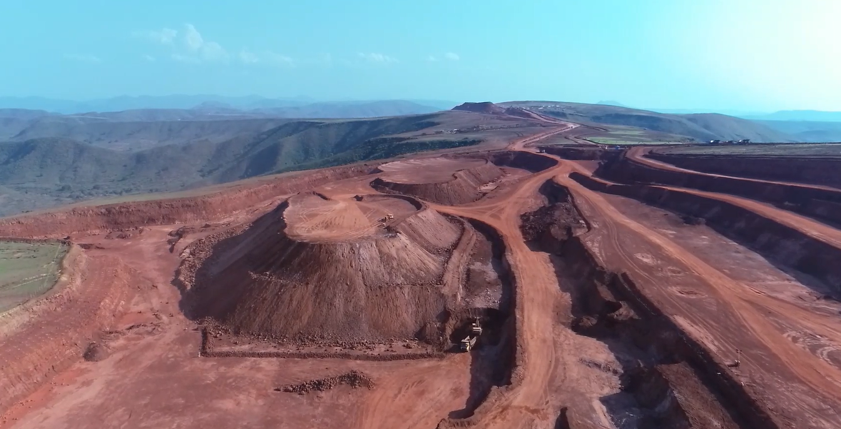

Authorized By:

- PURPOSE:

To provide the Standard Operating Procedure for Mine Excavation operation in Kodingamali Bauxite Mine.

- SCOPE:

This procedure is to provide a standard of operation to carry out Mine Excavation Operation safely in Kodingamali Bauxite Mine in order to achieve high level of safety with optimum productivity.

- RESPONSIBILITY:

 | Mine Excavation | Shovel operator & dumper drivers
 | HEMM Maintenance | Maintenance In-charge/Head Mechanical
 | Field Operation | Shift in charge/Foreman
 | Operational Control | Mine Manager/Asst. Manager authorized by M.M.

- SAFETY AND HEALTH HAZARDS:

- Slip/trip/fall.
- Roll Over/Toppling of Shovel & Dumpers.
- Head on Collision.
- Hitting to other Truck/Structure/Persons
- Dust generation during Operation.
- Noise during Operation.
- Vibration during Operation.
- Diesel/ Hydraulic Oil/solid wastes - Inflammable, Fire hazards.
- Acid Batteries- Skin contact can lead to extensive and severe burns and highly toxic.

- PRECAUTION TO BE TAKEN

In order to avoid injuries to personal and damage to machinery, the following precautions are very important.

- Use of PPE while at work i.e. with safety shoes, helmet, dust mask, fluorescent jackets, ear plug etc.
- Adherence to Traffic Rules guidelines framed by Mines Manager.
- Pre Operation Safety features checklist.
- Regular Checkups & scheduled Maintenance.
- Providing mine vocational training to excavator operator and dumper drivers.
- Evaluation of skill and competency of excavator operator and dumper drivers at regular interval by in house training personals.
- Conduct of safety meeting by safety committee once in a month.
- Conduct of periodical medical examinations of excavator operator and dumper drivers employed in mines.
- Use seat belt while driving.

Note: Report immediately to Supervisor, Shift Incharge and Safety officer for any incident/accident.

- ENVIRONMENTAL HAZARDS :

- Dust generation.
- Air Pollution.
- Water Pollution.
- Noise Pollution.
- Ground Vibration.
- Solid waste generation.

- PREVENTIVE MEASURES :

- Regular water sprinkling at place of excavation shall be done for dust control at the source of emission.
- The machine should be ergonomically constructed.
- Tightening of all screw and bolting in the machine appropriately.
- Proper greasing on frictional surface of the devices used in machine good track alignment.
- Effectively carrying out of schedule maintenance of machine in time to reduce emission of Carbon Dioxide, noise and wear n tear of internal parts.
- Use of Dust Mask/Earplug
- Identification and control of leakage.
- Formulation and implementation of systematic solid waste management in mines.

- TOOLS:

All Work required PPEs like Safety Helmet, Safety shoes, Nose mask, Ear Plug & fluorescent Jacket.

- PROCEDURE:

- Duties and responsibility of Mines Manger :

- The mines manager shall inspect the place of excavation subject to his daily supervision of mining operation and ensure that everything in respect to mine excavation is safe and the excavation operation is carried out in accordance with the provisions of mine regulations, rules, bye laws and any orders made there under.
- He shall meet to the shift in charge and other officials to assign their respective duties under his statutory duties where he shall duly explain the systematic mine excavation, the approach and extent of excavation and other job related safety to shift in charge.
- He shall take all possible steps to ensure that all materials and appliances are sufficiently available for smooth carry out of excavation operation in accordance with the framed SOP.
- He shall enter the findings of his inspection in the manager’s diary kept for the purpose.

- Duties and Responsibility of Asst. Mines Manager/Mine Foreman :

- The Asst. Mine manager or Mine foreman being the shift in charge duly authorized by the mines manager in writing shall inspect to ensure that place of excavation is safe to commence excavation operation. Thereafter, he shall deploy the shovel and dumpers to start mine excavation.
- The shift in charge shall not allow any unauthorized driving and any driver who are in a drunken or intoxication state.
- The shift in charge shall ensure that, all dumper drivers and excavator operator during their duty shall carry the driving license, company ID card, Mine manager’s authorization and shall produce the same on demand by mining officers at any time while at work.
- He shall make sure that all dumper drivers and excavator operator are competent persons and under gone vocational training or imparted job related internal training from in-house training staff before entering into mines.
- The shift in charge shall ensure that high level of safety and reduction in hazards to health and environment during the excavation operation is achieved. He shall also ensure that noise, dust, air pollutants associated to hauling operation is under permissible limit.
- He shall ensure that no excavation work is carried out with in 45 mts from any OHS lines and within safety zone.
- If heavy rainy with thunder storm occurs during work, he may stop the total excavation operation till the rain off or weather is cleared. The excavation operation shall resume only after a post rainy inspection is made by the shift incharge at the place of excavation.
- The shift in charge shall have a frequent visit at regular intervals to ensure that the excavation operation is carried out smoothly and safely to obtain optimum productivity and high level of safety. He shall also ensure that all the persons employed in mines under his supervision are discharging their respective duties in a safe and systematic manner and equipped with all PPE while at work
- He shall enter the findings of his inspection in the Asst. manager’s diary kept for the purpose.

III ) Duties of shovel operator & dumper driver :

- Pre-Operational Visual Checks:

- the excavator operator shall check the oil, fuel and water levels, under carriage unit, swing unit and general cleanliness to machine is maintained and sufficient available.
- The driver shall personally check the dumper for oils, fuel & water levels, tyre inflation, and general cleanliness, and inspect and test the Dumper. Special attention to the following shall be given-
    - Brakes and steering system are in proper working order.
    - Warning devices proximity sensor, fatigue device, seat belt reminder including
    - Automatic operated audio visual reversing alarm is in working order.
    - Rear view mirrors on both side of the Dumper are provided and in order.
    - Side indicator lights are in working order, and
    - Head lights are in working order, if the Dumper is required to work after day-light hours.
- Make sure that all safety devices are provided and in good order in the machine.
- Inspect the machine daily. Ensure that the routine maintenance and lubrication are being done dutifully.
- Check for warning or lockout tag on the machine.
- Repair or replace any malfunctioning, broken or missing part before use.
- Check the batteries and wire connections before starting the machine.
- Keep dumper in a clean and tidy condition and free from materials, lubricants, oil or grease.
- Make sure that all guards are in place on the machine.
- Check to see that propel, steering and lighting system are fully functional.
- Before starting or propelling the machine, check inside, outside and underneath the machine for people and obstruction.
- Know the location of emergency stop switch if the machine is equipped.
- Always know the limitation and capabilities of machine.
- Before starting the engine, check that all operating controls are in stop or neutral position and the emergency stop button is pulled out.
- Look for leaks in the fuel, hydraulic and engine oil.
- Setup And Start Precaution:
- Always inspect the engine before and after starting.
- Only use emergency stop button in an emergency.
- Start the engine from the operator console only.
- Use only water in the water injection system tank.
- Always sound the horn before starting the machine.
- Check gauge and controls for correct operation.
- Look out for any over-head electrical power line within the working area of the machine.

- Safety Precaution during Operation:

- The excavator operator shall not take out the machine for work or shall he operate the machine, unless he is satisfied that it is mechanically sound and in efficient working order.
- He shall wear the seat belt before starting the machine and shall not allow any person to enter into the operator’s cabin while on duty.
- The operator shall retain the ignition key with him or in his possession till the completion of shift and under no circumstances unauthorized operating shall be allowed strictly.
- In case any malfunctioning or failure of safety devices, the same shall be informed to the shift in charge or any person authorized by the mines manager and shall not start the machine until the break down is duly attended and rectified by a mechanical engg. Or any person authorized by the mines manager in this behalf.
- The shovel operator shall march the machine to the place of loading and place the shovel in a firm platform so as to allow front loading at a swing not exceeding 90degree per cycle safely. He shall put a safety bond in front of the front loading position at a appropriate distance so as to avoid the unexpected collision between dumper & shovel during their loading interaction.
- The shovel operator after confirmation that the machine is in position to load, give a signal by one time sound horn to the dumper driver to place the dumper for loading. Accordingly, the driver shall place the dumper for loading safely. the shovel operator shall start loading operation ensuring that the following safety measures are observed,
- The excavator bucket shall not be overloaded which may cause damage to dumper due to falling rock mass.
- The dumper is not over loaded then the carrying capacity.
- The whole weight of loaded material is loaded in a centralized manner avoiding big boulders which may align the dumper aside during hauling and unloading.
- No person is present within the danger zone i.e 3mts addition to the swinging radius of the machine.
- A clear road way free from loose boulders at loading point all the time.
- After loading operation is over, the shovel operator shall signal two time sound horn to dumper driver to leave the loading place and proceed to stockyard for unloading. The same procedure shall be followed on during the loading operation till the completion of the shift provided that No further instruction is given by the shift in charge regarding change in operation.
- The shovel operator shall not under cut or over cut the bench and maintain the bench at a slope 30degree to the vertical in a straight line pattern avoiding curves. In case any doubt arises, he shall confirm the bench safety parameters with the shift in charge.
- During marching, loading, climbing up or moving down the slope, the speed of the shovel shall not exceed 3 k.m per hour.
- If heavy rainy with thunder storm occurs during work, the shovel operator and the dumper driver shall stop the machine till the rain off or weather is cleared and the same shall be communicated to shift incharge immediately. Provided that no working shall be stopped during light rain fall or nature of rainy which may not impact the safety of man and machinery.
- The driver shall not take out the Dumper for work or shall he drive the Dumper, unless he is satisfied that it is mechanically sound and in efficient working order.
- He shall wear the seat belt before starting the Dumper and shall not allow any person to enter into the driver’s cabin while on duty.
- The driver shall retain the ignition key with him or in his possession till the completion of shift and under no circumstances unauthorized driving shall be allowed strictly.
- The driver shall keep the cab window clean so as to ensure clear vision at all times.
- The driver, during his duty shall carry the driving license, company ID card, Mine manager’s authorization and shall produce the same on demand by mining officers at any time while at work.
- The dumper drivers shall start the dumper and move the dumper front and back after a clear front and back view of up to 30mts.while it shall be strictly ensure that the seat belt is properly tied up all the time when the dumper is in starting position.
- After confirming the vehicle is fit and ready to work, the driver shall wait for the signal of the shovel operator to place the dumper for loading.
- The shovel operator after confirmation that the machine is in position to load, give a signal by one time sound horn to the dumper driver to place the dumper for loading. Accordingly, the driver shall place the dumper for loading safely.
- After loading operation is over, the shovel operator shall signal two time sound horn to dumper driver to leave the loading place and proceed to stockyard for unloading. The same procedure shall be followed on during the loading operation till the completion of the shift provided that No further instruction is given by the shift in charge regarding change in operation.
- Before leaving the loading point, it is important that the dumper driver satisfied himself that the total load is uniformly distributed and no big monster boulders are loaded which may cause toppling of dumpers during hauling.
- No mobile phones shall be carried out or allowed to carry by dumper drivers and excavator operator while on duty.
- After loading, they shall proceed to the earmarked dumps as instructed by the shift in charge for unloading.
- All drivers on duty shall strictly adhere to the Traffic Rules.
- At the end of the shift, dumper drivers and the excavator operator shall park the machine at a safe place at least 50 mts away from the HEMM movement area, where he shall switch off the machine and locking the operators / drivers cabin. He shall enter the shift report of the dumper/shovel maintained in a log book kept for the purpose and hand over the ignition key to shift in charge or any other person authorized by the mines manager with such communication of malfunctioning observed during his work, if any.
11) Repair & Maintenance:
- Ensure maintenance schedule.(Daily. weekly, periodically as per instruction manual).
- Maintenance should be done in workshop under the supervision of mechanical engineers.
- Maintain machinery log book data.
- If any Break downs taken place, inform immediately to the supervisors. if repairing to any break down which occur at work site takes more than 24 hrs, the site of breakdown shall be suitably barricaded to prevent any accidents.
- Inform proximity hazards in the work place to the immediate superior official.

